**The development of a soldering station**

|  |  |
| --- | --- |
| Author | Jasper Maes |
|  |  |

Content

1 Introduction 1

2 Material and methods 2

2.1 components 2

2.2 Pcb-soldering 2

2.3 PCB testing 2

3 Results 3

3.1 Schematic 3

3.1.1 Power supply 3

3.1.2 The main IC schematic 3

3.1.3 The display board 4

3.2 PCB 4

3.2.1 Design 4

3.2.2 Order and mounting 4

3.3 Finishing stage 5

4 Discussion 6

# Introduction

This document describes the complete assembly of a soldering station. Both technical details and physical aspects of the finished product are described. The design/build process is as well discussed.

The finished product will be able to drive a soldering iron based on user's selected value, to be seen on the display. The fully self-designed PCB (Printed Circuit Board) can read the temperature sensor located in the soldering iron. This information will be used to control the bolt temperature based on the user's setting. As a result, the soldering iron will maintain the desired temperature.

This project includes some basic circuitry, such as transistor circuits. However, it is not an overly complex circuit, which makes it an ideal way to get familiar with PCB design. Moreover, the final product is also useful, so it isn't a waste of money.

The project is based on an example from the 'Elektor' magazine. They already provided a schematic that was tested and worked without error. Based on this schematic, the soldering station being described here was made.

# Material and methods

## components

The BOM (Bill of Materials), [which can be found here](https://github.com/JasperMaes01/Project_Design_Soldering_Station/blob/933bf7efab9823fb29a891ee08f7afd323ac9bea/BOM_SolderingStation_JasperMaes.xlsx), describes which components were ordered to realize this project. As showed in the BOM, the total price of all components is € 99,28. Most components are ordered from Farnell.

The resistors and capacitors used were already available at school as SMD (Surface Mounted Device). This is why a conscious decision was made to use SMD for these components. All other components are trough hole as is easier to solder, and more convenient to debug. Moreover, a trough hole component is easier to replace if broken.

## Pcb-soldering

The PCB was soldered entirely by hand. The SMD components were also soldered manually. This is because, for those few SMDs, it is expensive to order stencils, which are needed to apply soldering paste.

Soldering was done using the schematic (in Altium Designer, see 3.1) and Elektor's example schematic. This allows any eventual design errors to still be resolved hardware-wise.

## PCB testing

While soldering the PCB, despite the many controls on the schematic, some errors were still found. One of the three lanes to the OKI DC/DC converter had not been drawn by Altium Designer's autoroute function. This was easily solved with a simple wire bridge.

The footprint of the BC557 transistor was wrong. This was solved by simply plugging the transistor in reverse. The same applied to the 4700µF capacitor. The footprint for this had also been placed in reverse.

Before connecting the finished product to grid voltage, some tests were done on the circuit. Using an Ohmic measurement, all circuits were thoroughly checked for short circuits. The +5VDC circuit was checked and appears to be fully correct. No bugs were found at this stage.

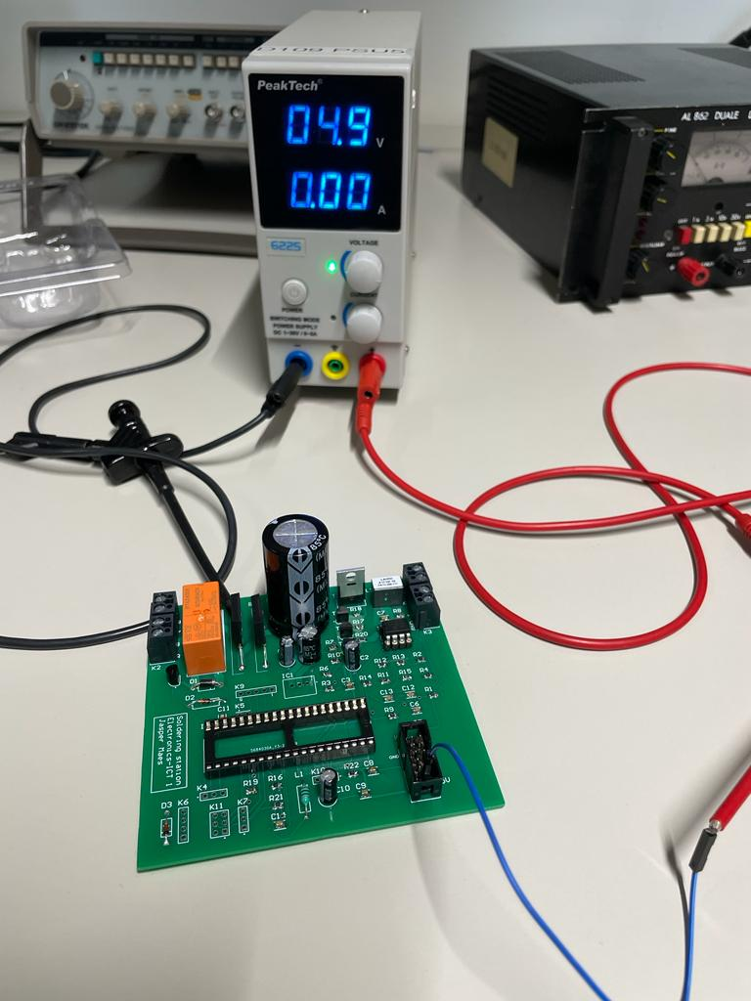

Figure 1: troubleshooting by applying 5VDC

Once these tests were done, the toroidal transformer was connected. This was not immediately connected to grid voltage, but to an adjustable AC power supply. This allows us to calmly increase the input voltage. As the voltage is driven up, all voltages are constantly monitored. The voltages in the 5V circuit are measured in several places.

At one point during testing, a small pop could be heard. At an input voltage of about 60 VAC, something blew up, with accompanying smoke. After a few measurements, it could be concluded that the OKI DC/DC converter had broken down, causing the DC voltage (normally 5VDC) to jump through to a whopping 11VDC. This put too high a voltage on the ATMEG, which also started smoking.

Even after some investigations and testing of different circuits, it is unclear what exactly caused this problem.

When applying 5VDC (see Figure 1), no exceptional values were measured anywhere. The voltages seem to be correct. This suggests that the problem will be somewhere in front of the OKI DC/DC converter.

# Results

The project can be divided into three main parts. Firstly, the schematic, secondly, the PCB design. As a finishing touch, a case will be designed and 3D-printed.

## Schematic

The schematic design consists of 5 parts:

* The soldering iron controller
* The power supply
* The temperature measurement
* The main IC schematic
* The display board

Three of them are highlighted below.

### Power supply

The power supply is where all the voltages enter. It is provided by the toroidal transformer whose input voltage is 230VAC. This is supplied by the euro connector, which contains a 250V fuse. The transformer has a power of 60VA, and the output voltage is 2 X 12VAC. So, the input voltage of our PCB will be 2 X 12 V. That voltage is connected to K1 and K2. Here they form the 2 important circuits.

The first circuit is the one for +5VDC. The input voltage is rectified by the bridge rectifier (in this case B2) and goes to the DC/DC converter. From this point we can tap a constant voltage of 5V for our electronic components (e.g. ATMEGA,...).

The other input voltage is used, sometimes in combination with the previous one, to power the bolt. Software programming can determine how much voltage the bolt needs for proper operation. If the bolt needs only a lower voltage, the relay will be switched off by software. This allows the voltage to the bolt to be software controlled.

The PWM signal driving the bolt is sent to K8 and K3 via the MOSFET to ensure that the bolt receives the right, amplified signal. The common mode choke (L2) located in front of the output (K8) serves to suppress RF noise on the cable of the bolt.

### The main IC schematic

The schematic of the main IC shows the following things.

The VDD pins. This is where the voltage at which the processor operates comes from. This is 5VDC and is simply tapped from the +5V circuit discussed in the section above. The ground pins are obviously equally important.

At the place where the voltage comes in (at the level of VDD) is an LC circuit that provides a noise filter. On the PCB, these were therefore placed as close as possible to the ATMEGA, to ensure the highest quality signal.

Connected to the PA pins there is the connector (K12) which is used to connect to the displayprint.

The other circuits, such as temperature measurement, bolt control and power supply, were also connected to the ATMEGA.

Additional pin headers were provided on this schematic in case the user would want to connect some extras. During soldering, these pin headers were not placed, as they are unnecessary, but each pin of the ATMEG has been brought to a header.

### The display board

On this diagram, the other side of the connector is provided. This is connected to K1 with a flat cable. In this way, you can flexibly go from the main board to the display board. This PCB contains the rotary encoder with internal pushbutton. This serves to set the temperature.

Additionally, the TM1637 can also be found on this circuit. This chip controls the 4-digit 7-segment display. The advantage of this chip is that it can be controlled with only 2 ports. This allows us to transfer all information from the display board to the main IC board (and vice versa) using only a few ports and cables.

This design will be placed in a separate project to make it a stand-alone PCB. This in order to place the PCB separately in the 3D design of the case.

## PCB

The PCB is where the magic happens. The above schematic was created entirely in Altium Designer. After carefully checking the PCB, it was ordered and assembled.

### Design

Altium designer was used to design the PCB. That is a software package used to design schematics and associated PCBs.

Before starting the project, component libraries were created. These consist of the schematic representation of the components, and their footprints. Once these are made, design can start smoothly.

The design has two main parts. The schematic part, and the PCB part. These are, at their turn, split into two separate projects. That's because in that way we have no physical connection between the main PCB and the display PCB. Later on, they will be connected via a flatcable.

The main PCB consists of 4 schematics. Bolt control, power supply, temperature measurement and the main IC sheet. These are subdivided and linked with 'ports'. This function in Altium Designer allows us to divide the schematic into several sheets. That way, everything stays clear.

On the displayprint, you can find everything that was described above (see 3.1.3 The display board).

Based on the schematic design, the PCB design was generated. After some manual adjustments to the structure, Altium's auto routing tool was used to properly lay out the lanes. After several people had carefully checked the design, the PCB was ready for order.

### Order and mounting

The PCB was ordered on JLCPCB. That is a Chinese company that makes PCBs based on submitted design. The PCB was delivered smoothly and is of good quality.

As soon as the PCBs arrived, work started on mounting the PCB. First, the SMDs were placed, then all components were placed from small to large.

While mounting the PCB, it was concluded that there were still some errors on the PCB. The footprints of the bridge rectifiers are not correct, as well as the one of the TM1637 IC on the display PCB. This IC is responsible for decoding the signal for the 7-segment display. Because of this error, the displayprint in its current design will therefore never work.

## Finishing stage

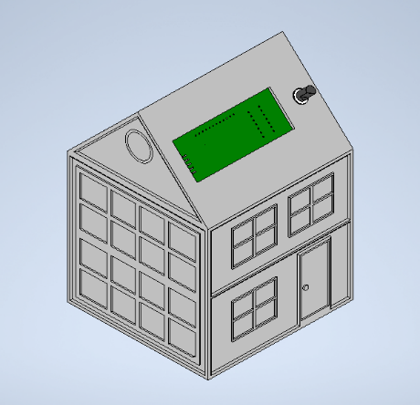

Figure 2: 3D design front view

The PCB is assembled into a 3D printed design. A house was chosen for this design.

The design was drawn entirely in Autodesk Inventor. The design includes appropriate holes for the knob (the rotary encoder on the dispalyprint), the 7-segment display and the power connector.

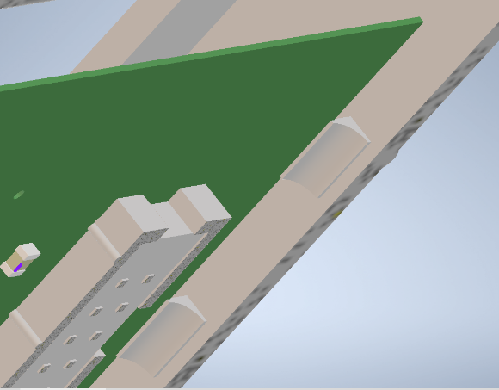

Figure 3: Displayprint mounting system

Screw holes were deliberately not chosen in the PCB design. Alternatively, a slot was provided to slide the PCB in. A click system was designed for the display PCB.

Figure 4: Toroidal transformer, located under PCB

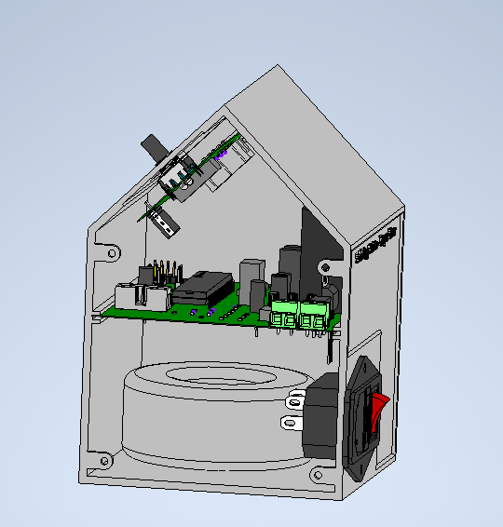

Below the main PCB, the toroidal transformer is located. It is fixed with the supplied plate. The screw holes for this are provided at the bottom of the design.

Once all components are in place, the design can be closed with the screw holes provided. With 4 bolts (M3) the design can be closed nicely.

As there are some errors in the PCB design (see 3.2.2), it was decided not to physically print the 3D design. There is not much added value in putting a non-working project into a case. However, the images on this page do show what the final design would look like with the PCBs and connectors inside.

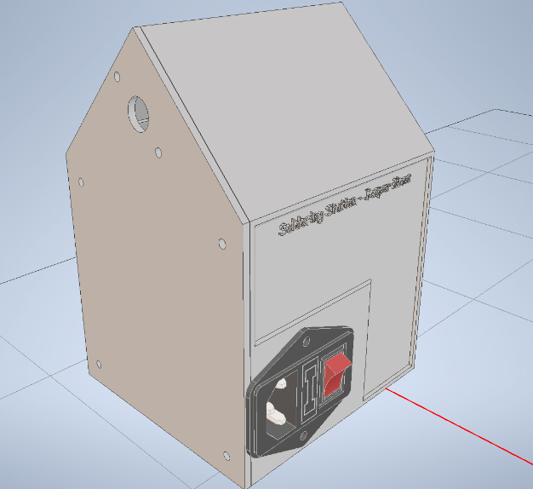

Figure 5: Back view, closed case

# Discussion

Although not everything went as planned, it has been a very informative project. The schematics show the circuits from the electronics classes. It is interesting to see how these circuits can be used in reality.

In the schematics, despite many checks, there were still errors. Most of them were easy to solve, and they were. But there is still an error on the PCB that is so far unknown. While unfortunate, that was still an interesting learning opportunity to learn new test methods. With a bit more time, it would certainly have been possible to fix the error and possibly improve it in a new version of the PCB.

With the PCB not working, it was pointless to print a case. This is a shame, but the case design is ready and would be a perfect fit for the PCB.

If it were possible to do this project again, I would make sure the PCBs pass an additional check. In the perfect scenario, a test PCB is ordered first. If there are any errors on this, they are fixed to order the official PCB.

The current design is certainly not wasted. A few more tests should be done on the PCB to find the error. Once the error is known, a new PCB must be ordered, as well as the broken components (OKI and ATMEG). That should suffice to have a perfectly working soldering station with the current components.